**INT 301-Open Source Technologies**

**CA3 Project Report**

**On**

**Capturing and analysing the browser history using any opensource tool.**

**Submitted by**

Name: Reddy Charan Reddy P

Reg No: 11906885

Roll No: 16

School Of Computer Science Engineering

Lovely Professional University

Phagwara

**INTRODUCTION**

**What is browser history?**

A browser history is a record of the websites that a user has visited using a web browser. It typically includes the URLs of websites, the date and time of the visit, and any titles or descriptions associated with the pages visited. Browsers maintain a history to help users revisit previously viewed pages quickly, as well as to help with autofill of previously entered information. Users can often view their browsing history by accessing the browser's history menu or by using keyboard shortcuts. Some browsers also offer the ability to clear browsing history, either selectively or entirely, for privacy or security reasons.

**Objective of the project**

The objective of the project is to capture and analyse the browser history using any opensource tool and perform a scan of bookmarks, cache data, visited websites and cookies. For this we are going to use fiddler tool.

**Fiddler Tool**

Fiddler is a free web debugging proxy tool that can be used to monitor, intercept, and modify HTTP(S) traffic between a web browser and a server. It was developed by Eric Lawrence of Telerik and is now owned by Progress Software Corporation. Fiddler is commonly used by web developers and testers to troubleshoot web applications, analyze performance issues, and test security vulnerabilities. It allows users to capture and inspect HTTP requests and responses in real-time, as well as manipulate and replay traffic to simulate different scenarios.

Some of the key features of Fiddler include:

Request and response capturing and analysis

HTTP and HTTPS decryption

Performance profiling and tuning

Automatic breakpoint insertion

Traffic manipulation and replay

Scripting support through .NET languages

Compatibility with most web browsers and platforms

**Execution of the Project**

**How to use fiddler**

First we need to download and install Fiddler from the Telerik website which is available for free. Then we should launch the application. We have to configure fiddler to capture browser traffic by going into tools->options->HTTPS and check both “Capture HTTPS Connects” and “Decrypt HTTPS Traffic”.Graphical user interface, text, application

aNow we can open a browser from which we want to capture the history and visit some tabs.

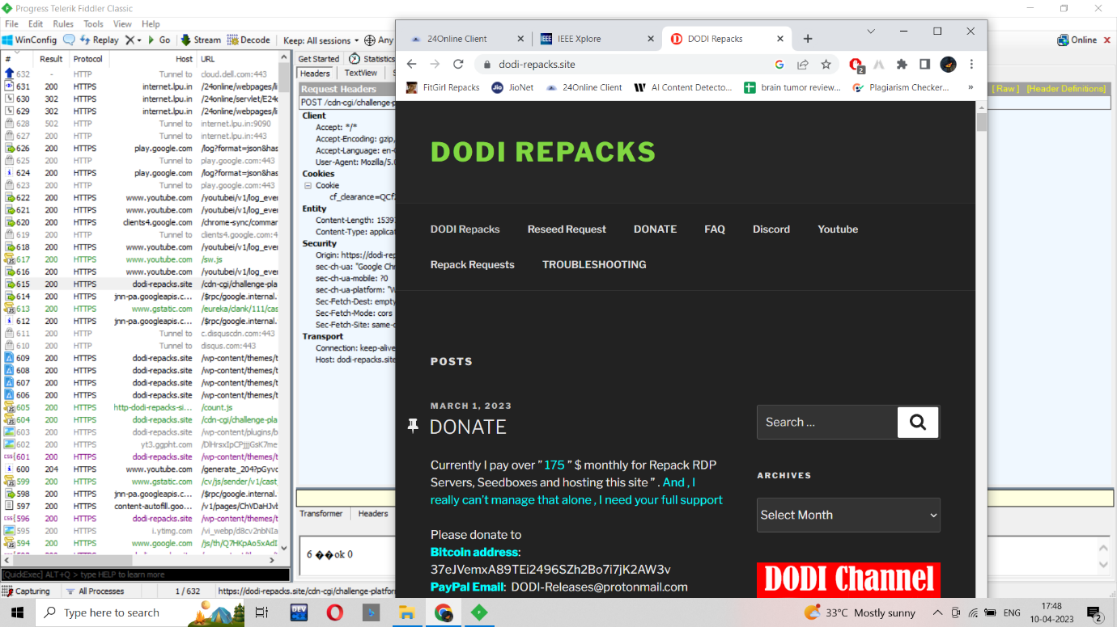

Now if we look in the right side of the screen we can see the list has been updated. In order to inspect a particular website we visited we must click on that and all the information we need for analysis will be visible to us. For example I visited a youtube in the chrome browser and it got captured like shown in the image below.

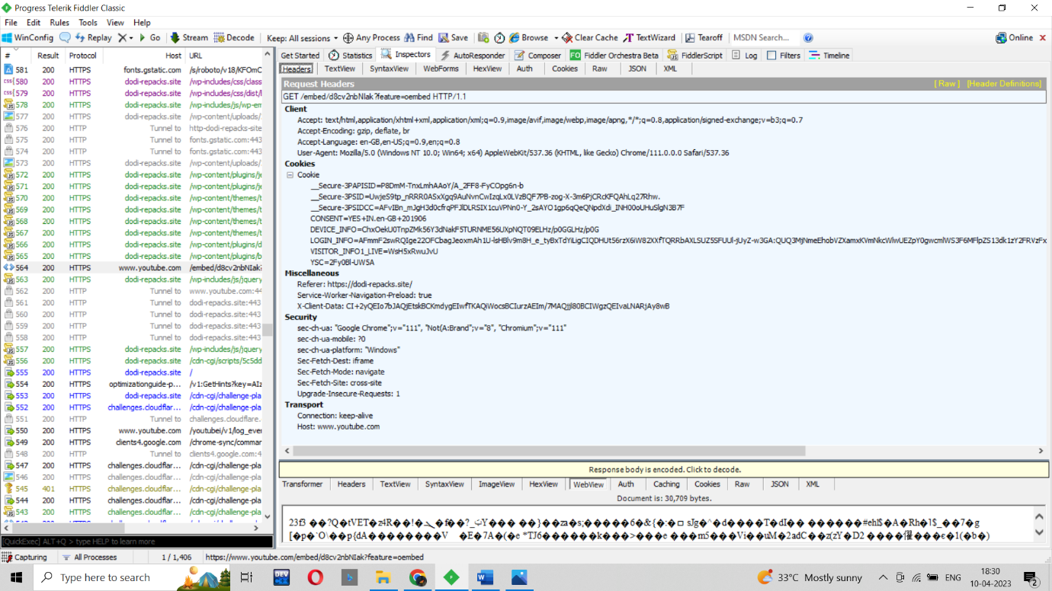

All the details we need for the analysis is mentioned in the rightside like cookies, cache etc. If you specifically want some information you can select from the top menu.

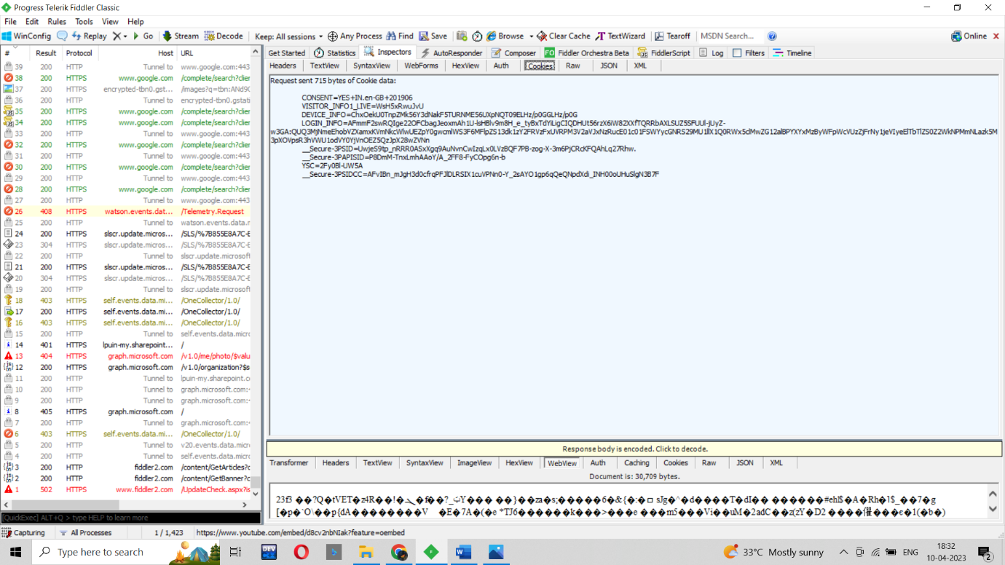

**References**

Youtube